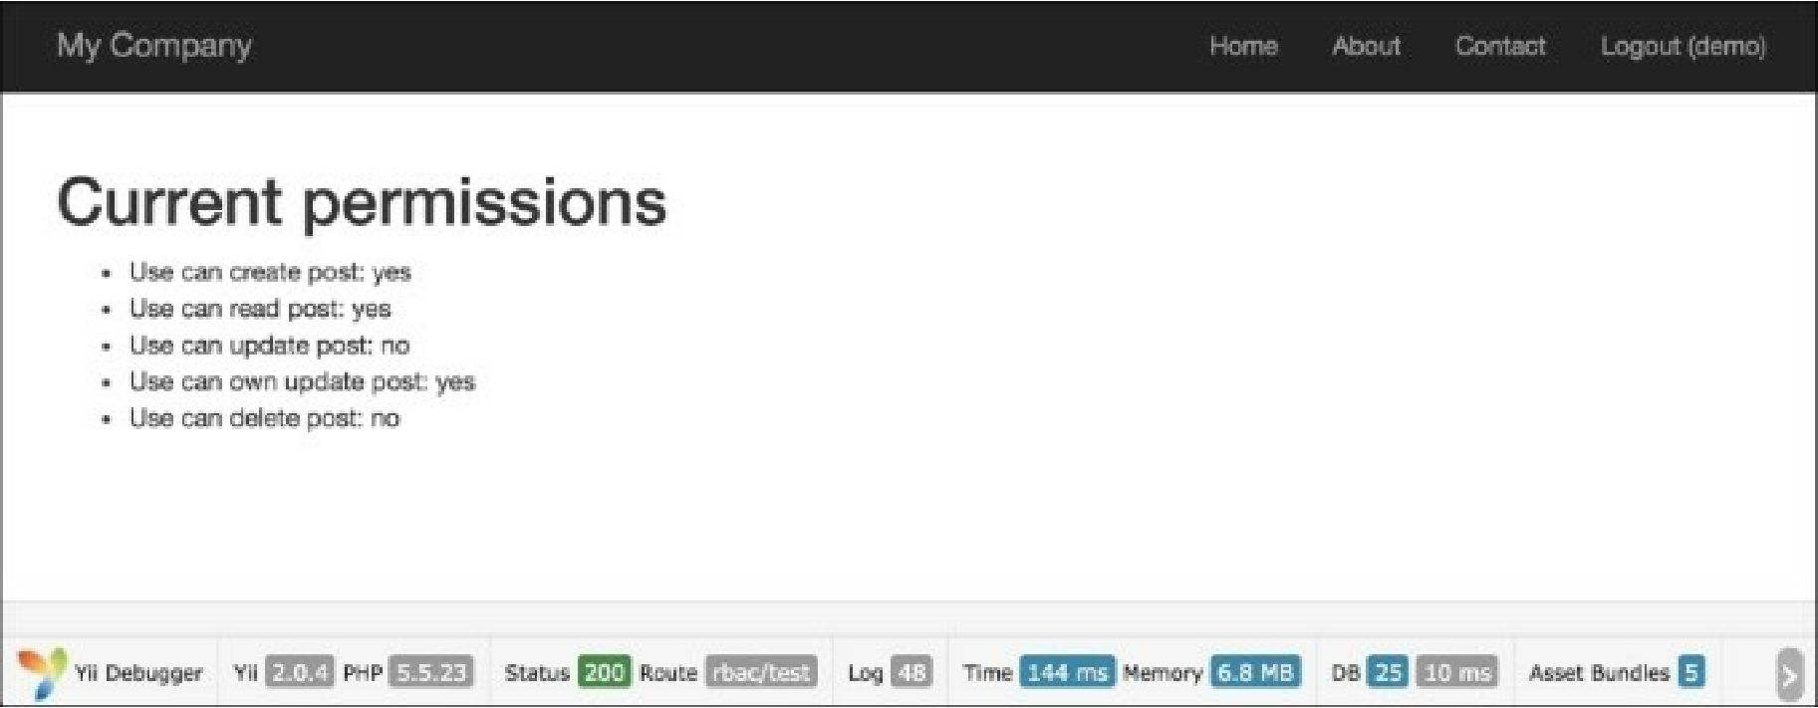

7. Then, try to log in as admin (the password is admin) and run rbac/test again:

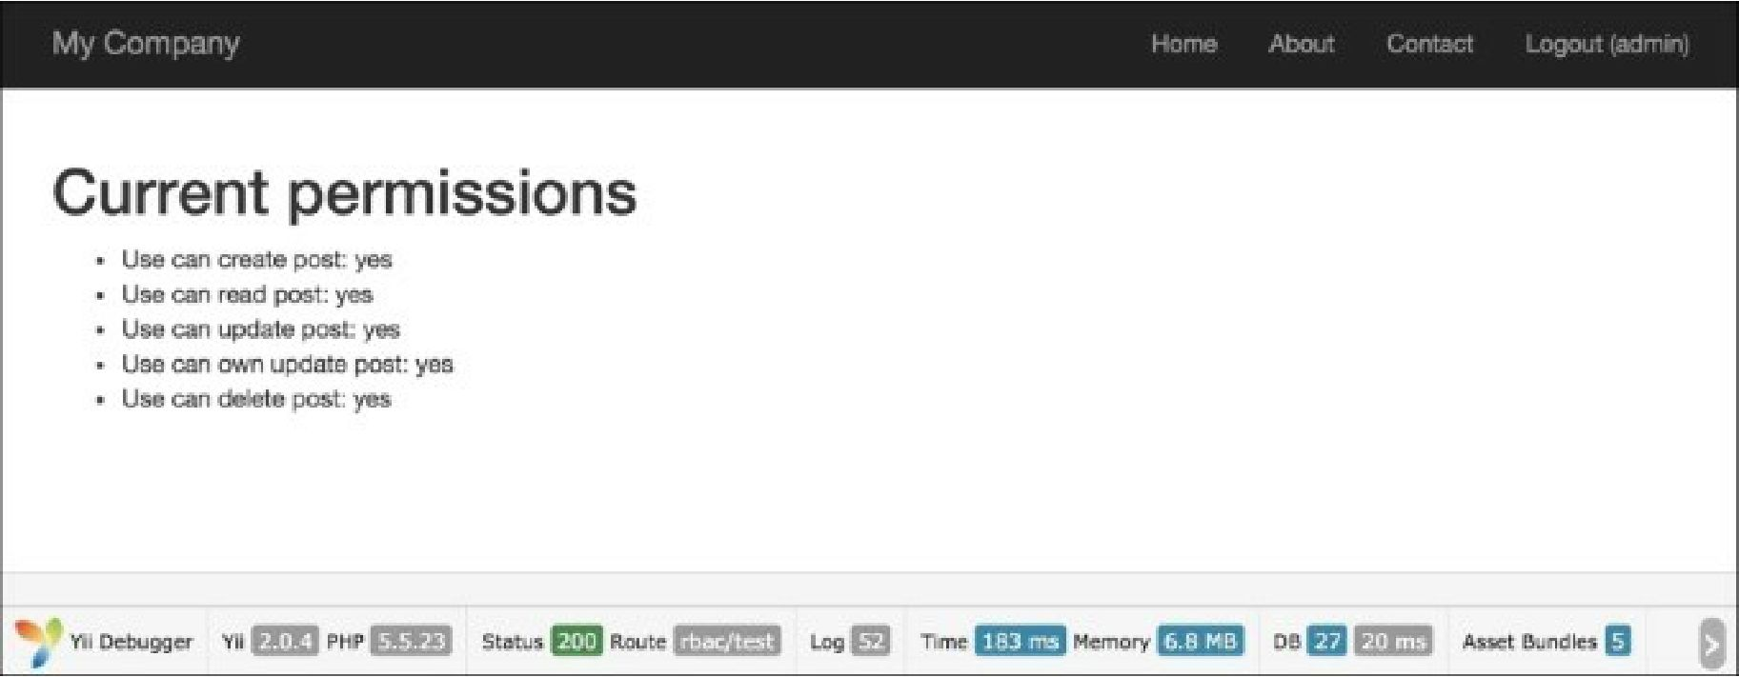

8. Log in as demo user and run rbac/delete: